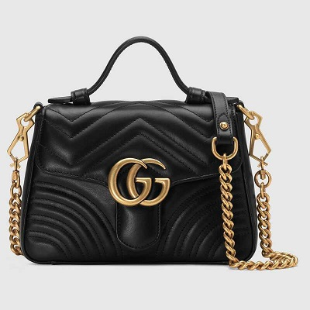

GG Marmont mini top handle

Bag

PRODUCT DETAILS

**Antique gold-toned hardware**

**• GG Marmont**

**• Double G**

**• Leather handle with 2.5" drop**

**• Detachable chain strap with leather detail with 21.5" drop**

**• Interior open pocket**

**• Made in Italy**